**Tank Design**

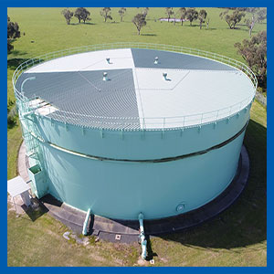

Tanks built today need to meet future WH&S requirements, provide long term value for money and be adaptable to service area needs and volumes.  
  
Allow for future renovations and ongoing maintenance.  
  
Minimise tank equipment that will need maintenance – remove gutters and make roof areas ‘self shedding’ to reduce the amount of debris that can accumulate and affect water quality.

Missing roof sheeting or unsecured items, impacts from the neighboring environment (trees), leaf litter build up causing ponding and corrosion.