Creating a Project Management (PM) template against a defect noted in the External or Internal Maintenance reports, enables the client to record and update the renovation progress through to completion. Four PM categories can be created – OH&S, Water Quality, Structural or Security. Reports can be generated at any time to give an update on the project outcomes.

Please note that some of the more advanced features of the Project Management System

(General Projects) are only available under an editing licence for ASAM. Please contact the ASAM administrators listed below for more details.

Projects may include:

* Entry Hatch and/or platform upgrades
* Ladder renovations
* Roof repairs or replacements
* Re-coating works
* Safety installations
* Ventilation upgrades
* Or any other works!

**Login to ASAM and open an asset of interest.**

1. Login to ASAM and open an asset of interest that has issues identified from an inspection report, such as unsecured roof sheeting, unsealed entry hatch or coating failures etc.
2. Open a Condition report for the External or Internal feature of interest.

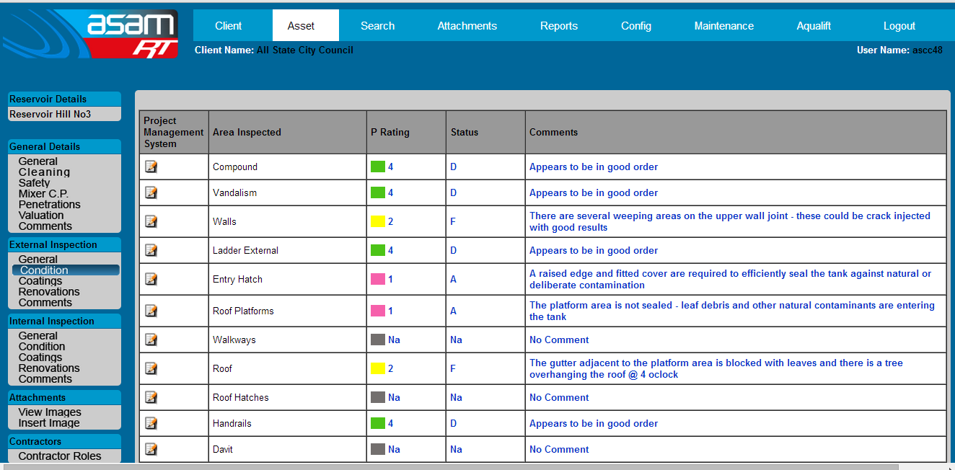

1. Against the area of interest, select the button for ‘Project Management System’ and say OK to proceed if this is the intent. (A project registry can be deleted at a later date if this is just a demonstration of the system).

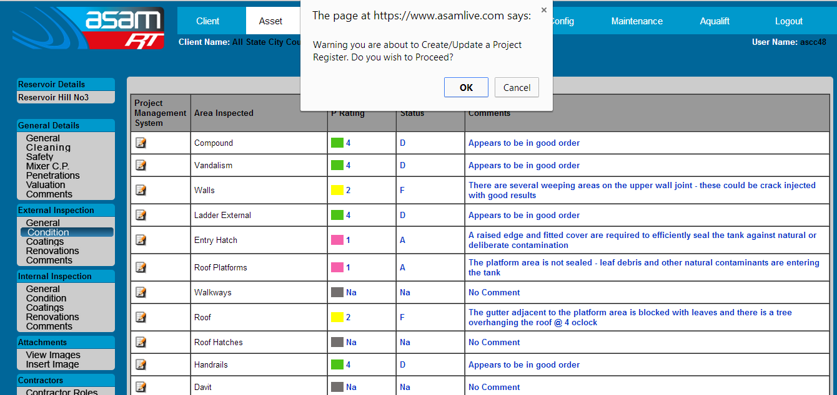

1. Select the appropriate category for the project.

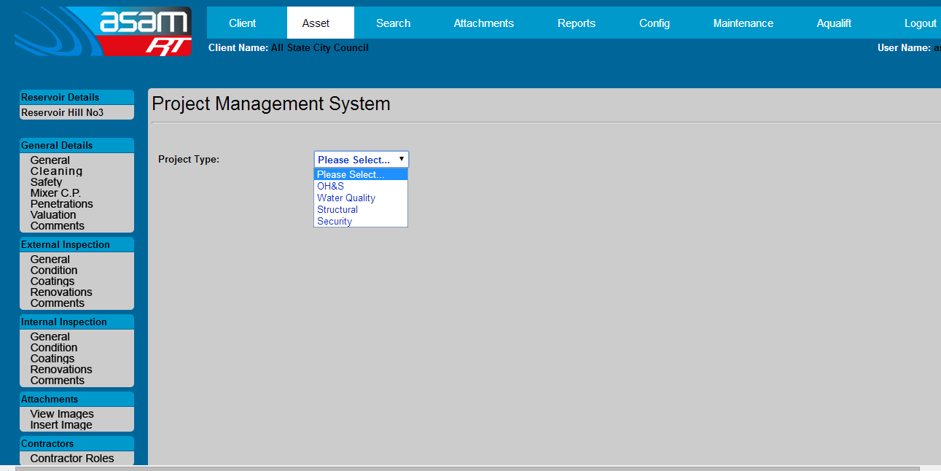

1. A Project Management template is created listing the basic information from the inspection report. Fields can then be filled with dates and text as the project develops.

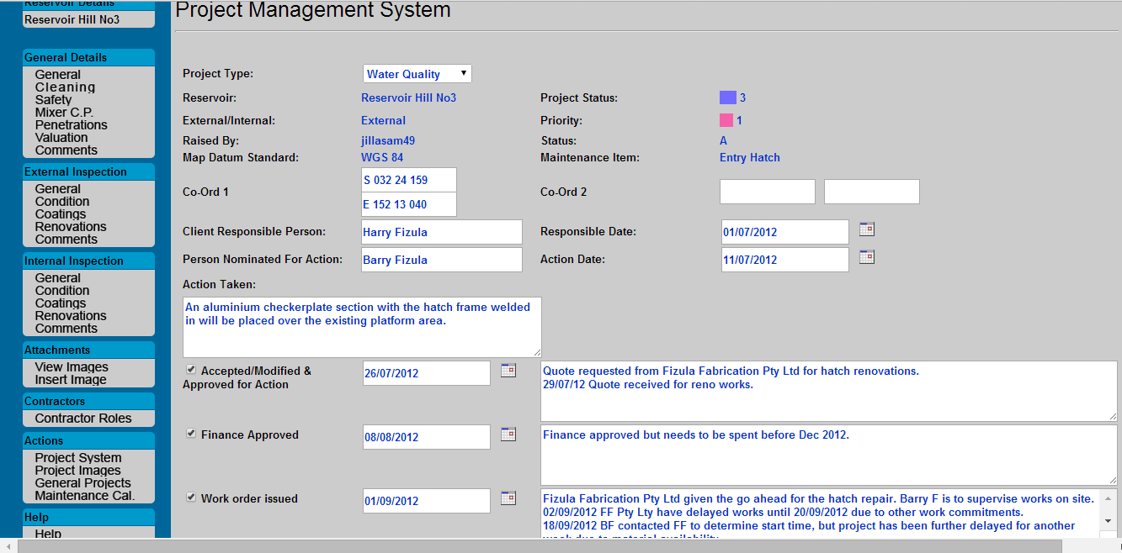

1. After entering information, remember to save by selecting the ‘Update’ button.

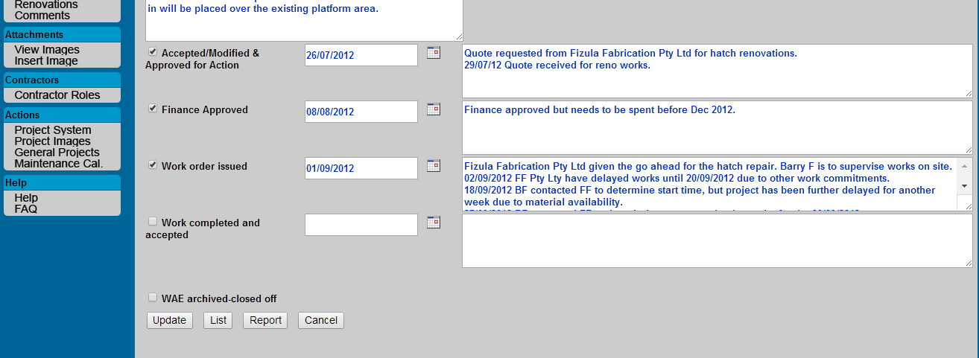

1. To review, edit, or create a report, select Project Systems to view the current projects and their progress paths (which are color coded, red through to green).

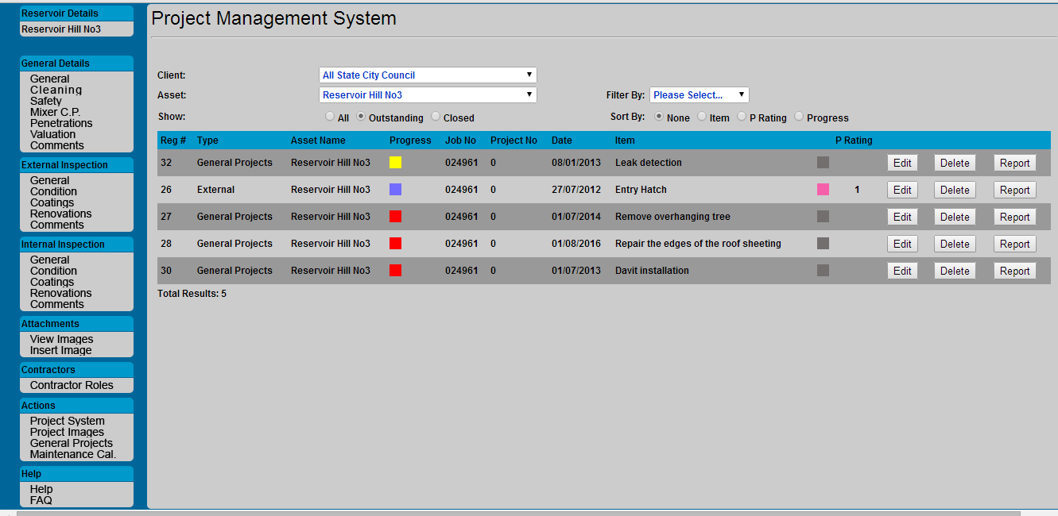

1. Images can be viewed or inserted against each project. It is recommended that Image file names are prefixed with the project registration number number followed by a sequential number (eg. 26 001, 26 002, 26 003 etc.). This is important, as images are stored in a common attachments folder (specific to the client) and will be ‘overwritten’ if the same file names are used. This process of image collection allows for a progressive photographic record to be assembled as the project develops.

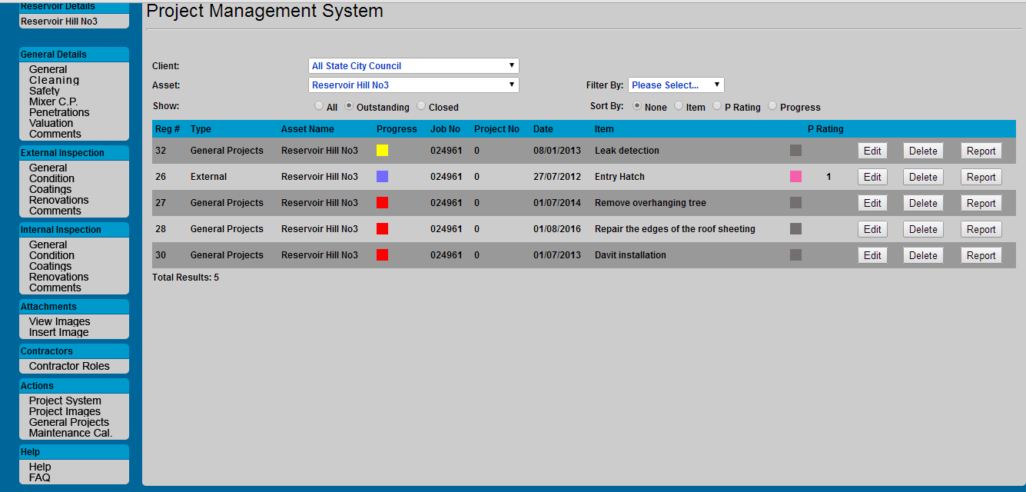

Comments can be added in against the images for additional detail to the project

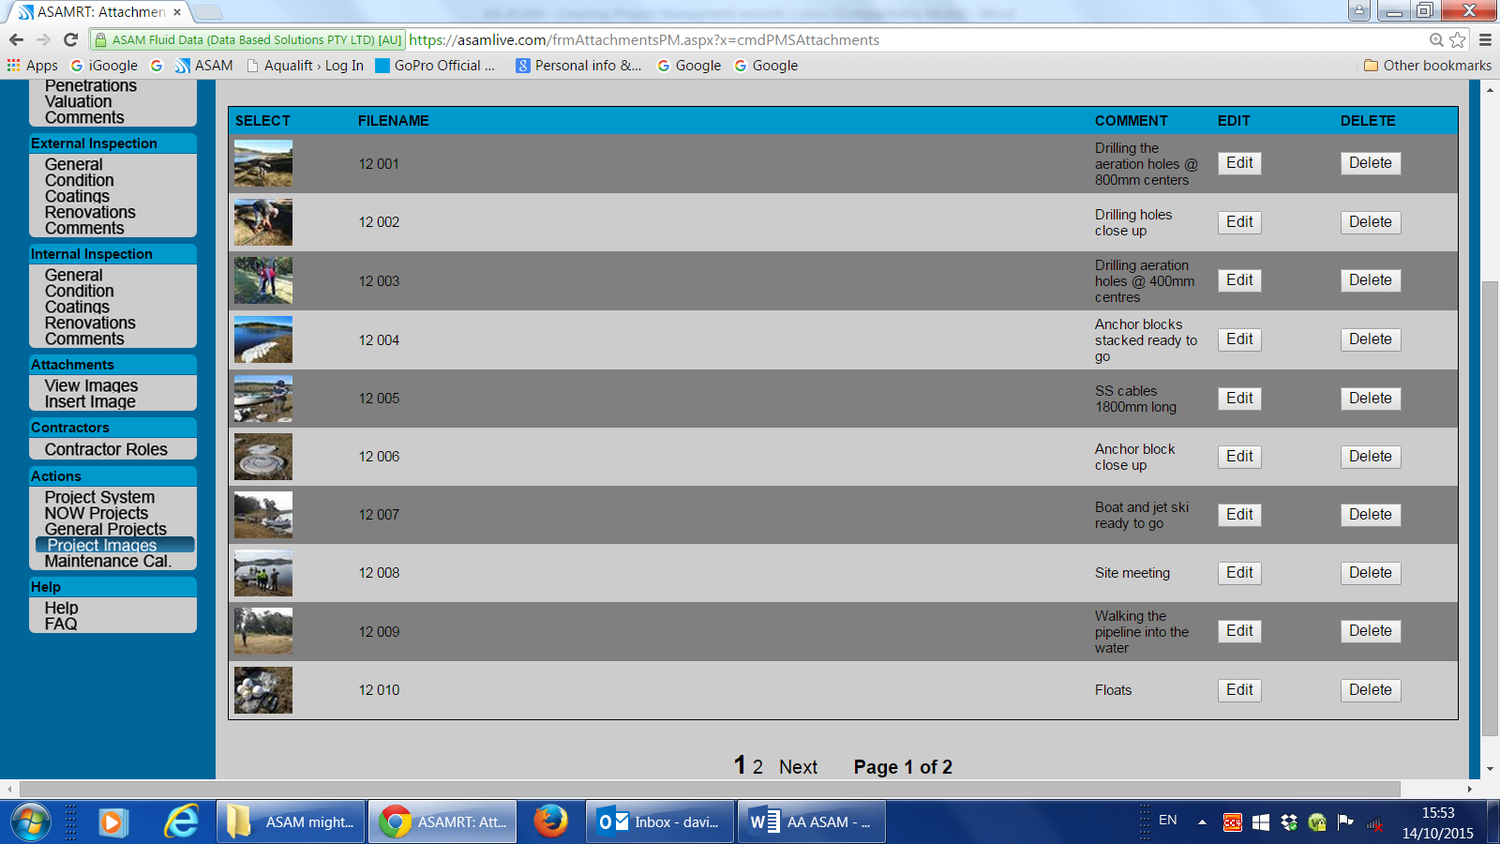

1. A project report can be created and exported into the various document formats such as Word, PDF, etc. along the way.

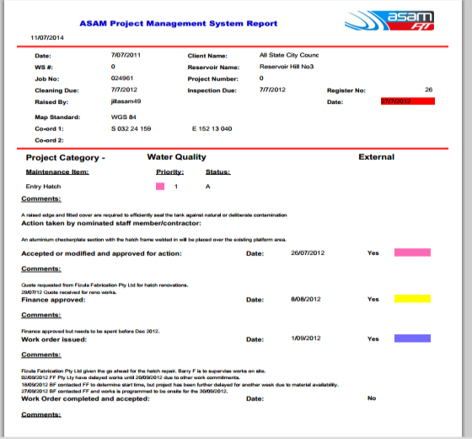

10. **General Projects** – this is an additional PM area that is only available to licensed users. There are eight, colour coded catagories available for more specific renovation projects:

1. External coating
2. Roof re-newal
3. External coating and roof re-newal
4. Internal coating
5. Internal coating and roof re-newal
6. Miscellaneous CAPEX (for any other type of Capital project)
7. Miscellaneous OPEX (for any other type of Operational project)
8. Level 1 Inspection – all external areas with limited internal features
9. Level 2 inspection – all external and internal areas inspected

11. A programing maintenance calendar for an individual asset or across an entire client asset base can be created and viewed in ASAM. This calendar is linked to General Projects and allows for multiple sections within an organisation to create and keep ‘up to date’ with programs of works that are scheduled in the coming years for assets .

